# STUDENT VERSION (Week-2)



**Meeting Agenda**

▶ Icebreaking

▶ Questions

▶ Video of the week

▶ Retro meeting

▶ Coding Challenge

# Teamwork Schedule

## Ice-breaking 10m

Personal Questions (Stay at home & Corona, Study Environment, Kids etc.) Any challenges (Classes, Coding, AWS, studying, etc.)

Ask how they’re studying, give personal advice. Remind that practice makes perfect.

## Team work 10m

Ask what exactly each student does for the team, if they know each other, if they care for each other, if they follow and talk with each other etc.

## Ask Questions 15m

### In On-Demand instance model, each virtual machine has an price.

* 1. Yearly
  2. Weekly
  3. Hourly
  4. Monthly

## İstek Üzerine Fiyatlandırma

İsteğe Bağlı bulut sunucuları, işlem kapasitesi için uzun vadeli taahhüt olmaksızın saatlik veya saniyelik (en az 60 saniye) ödeme yapmanıza imkan tanır. Bu sayede donanım planlama, satın alma ve donanım bakımı yapmanın getirdiği maliyetlerden ve karmaşıklıklardan kurtulabilir, genellikle büyük ve sabit olan maliyetleri daha küçük ve değişken maliyetlere dönüştürebilirsiniz.

### Encapsulation is the process of taking data from one protocol and translating it into another protocol, so the data can continue across a network.

1. True
2. False

With networking, **encapsulation** is taking data from one [protocol](https://www.computerhope.com/jargon/p/protocol.htm) and translating it into another protocol, so the data can continue across a network. For example, a [TCP/IP](https://www.computerhope.com/jargon/t/tcpip.htm) packet contained within an [ATM](https://www.computerhope.com/jargon/a/atm.htm) frame is a form of encapsulation.

With programming, **encapsulation** is information in a module or section of code that enables the program or programmer to use code contained within a program.

### Which command is used for modifying a user's properties?

* 1. who am i
  2. sudo su
  3. usermod
  4. groupadd

usermod command in Linux with Examples

usermod command or modify user is a command in Linux that is used to change the properties of a user in Linux through the command line. After creating a user we have to sometimes change their attributes like password or login directory etc. so in order to do that we use the Usermod command. The infomration of a user is stored in the following files:

* /etc/passwd
* /etc/group
* /etc/shadow
* /etc/login.defs
* /etc/gshadow
* /etc/login.defs

When we execute usermod command in temrinal the command make the changes in these files itself.

**Note:** usermod command needs to be executed only as a root user.

### Working with usermod command

**1.** To add a comment for a user

sudo usermod -c "This is test user" test_user

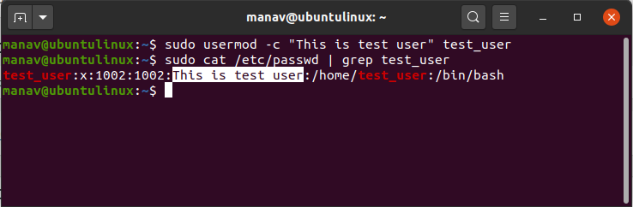

This will add a comment about the user or a short description related to the user.

**2.** To change the home directory of a user

sudo usermod -d /home/manav test_user

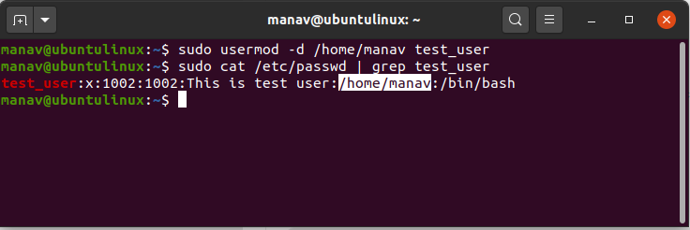

This will change the home directory of the user to /home/manav.

**3.** To change the expiry date of a user

sudo usermod -e 2020-05-29 test_user

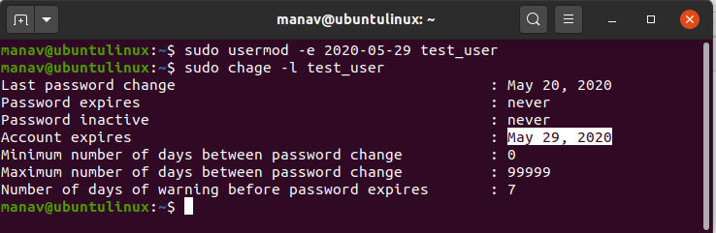

This will change the expiration date of account “test_user”

**4.** To change the group of a user

sudo usermod -g manav test_user

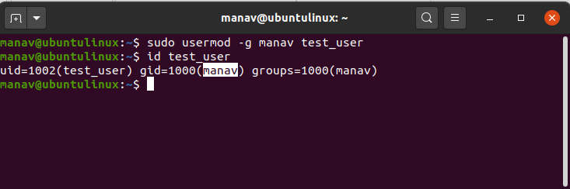

This command will now change the group of test user from test_user to manav

**5.** To change user login name

sudo usermod -l test_account test_user

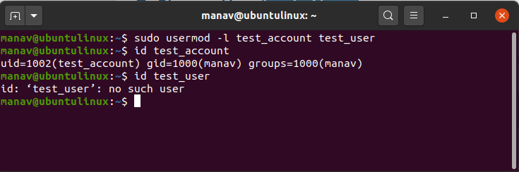

This will now change the login name of the user “test_user”.

**6.** To lock a user

sudo usermod -L test_user

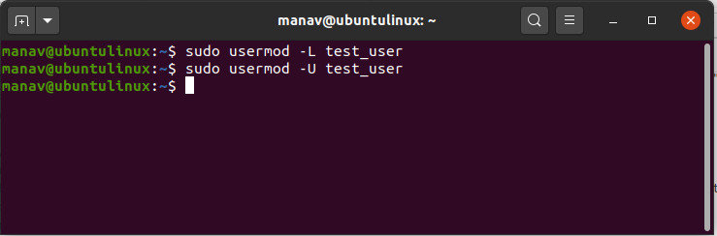

This will lock the “test_user” account and will display a! sign in shadow file before the username

**7.** To unlock a user

sudo usermod -U test_user



This will unlock the “test_user” which was locked by the previous command

**8.** To set an unencrypted password for the user

sudo usermod -p test_password test_user

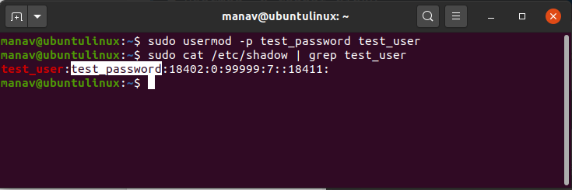

This will set the password “test_password” in the unencrypted form for the user “test_user”

**9.** To create a shell for the user

sudo usermod -s /bin/sh test_user

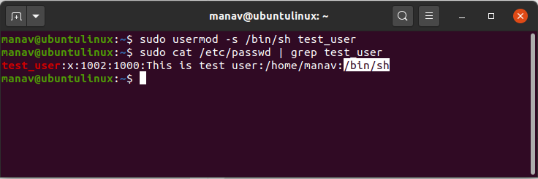

This command will now create a shell for the user “test_user” from /bin/sh

**10.** To change the user id of a user

sudo usermod -u 1234 test_user

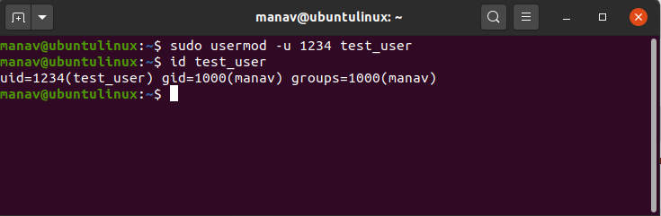

This command will change the user id of “test_user” to 1234

### The network address of 172.16.0.0/19 provides how many subnets and hosts?

* 1. 7 subnets, 30 hosts each
  2. 8 subnets, 8.190 hosts each
  3. 8 subnets, 2.046 hosts each
  4. 7 subnets, 2.046 hosts each

Explanation:

A CIDR address of/19 is 255.255.224.0. This is a Class B address, so that is only 3 subnet bits, but it provides 13 host bits, or 8 subnets, each with 8,190 hosts.

## Subnet Zero

If a network address is subnetted, the first subnet obtained after subnetting the network address is called subnet zero.

Consider a Class B address, 172.16.0.0. By default the Class B address 172.16.0.0 has 16 bits reserved for representing the host portion, thus allowing 65534 (216-2) valid host addresses. If network 172.16.0.0/16 is subnetted by borrowing three bits from the host portion, eight (23) subnets are obtained. The table below is an example showing the subnets obtained by subnetting the address 172.16.0.0, the resulting subnet mask, the corresponding broadcast addresses, and the range of valid host addresses.

|  |  |  |  |
| --- | --- | --- | --- |
| **Subnet Address** | **Subnet Mask** | **Broadcast Address** | **Valid Host Range** |
| 172.16.0.0 | 255.255.224.0 | 172.16.31.255 | 172.16.0.1 to 172.16.31.254 |
| 172.16.32.0 | 255.255.224.0 | 172.16.63.255 | 172.16.32.1 to 172.16.63.254 |
| 172.16.64.0 | 255.255.224.0 | 172.16.95.255 | 172.16.64.1 to 172.16.95.254 |
| 172.16.96.0 | 255.255.224.0 | 172.16.127.255 | 172.16.96.1 to 172.16.127.254 |
| 172.16.128.0 | 255.255.224.0 | 172.16.159.255 | 172.16.128.1 to 172.16.159.254 |
| 172.16.160.0 | 255.255.224.0 | 172.16.191.255 | 172.16.160.1 to 172.16.191.254 |
| 172.16.192.0 | 255.255.224.0 | 172.16.223.255 | 172.16.192.1 to 172.16.223.254 |
| 172.16.224.0 | 255.255.224.0 | 172.16.255.255 | 172.16.224.1 to 172.16.255.254 |

In the example above, the first subnet (subnet 172.16.0.0/19) is called subnet zero.

The class of the network subnetted and the number of subnets obtained after subnetting have no role in determining subnet zero. It is the first subnet obtained when subnetting the network address. Also, when you write the binary equivalent of the subnet zero address, all the subnet bits (bits 17, 18, and 19 in this case) are zeros. Subnet zero is also known as the all-zeros subnet.

## The All-Ones Subnet

When a network address is subnetted, the last subnet obtained is called the all-ones subnet.

With reference to the example above, the last subnet obtained when subnetting network 172.16.0.0 (subnet 172.16.224.0/19) is called the all-ones subnet.

The class of the network subnetted and the number of subnets obtained after subnetting have no role in determining the all-ones subnet. Also, when you write the binary equivalent of the subnet zero address, all the subnet bits (bits 17, 18, and 19 in this case) are ones, hence the name.

### What is the default subnet mask for a Class B address?

**A.** 255.0.0.0

**B.** 255.255.0.0

**C.** 255.255.255.0

**D.** 255.255.255.255

* Class A networks use a default subnet mask of 255.0.0.0 and have 0-127 as their first octet. The address 10.52.36.11 is a class A address. Its first octet is 10, which is between 1 and 126, inclusive.
* Class B networks use a default subnet mask of 255.255.0.0 and have 128-191 as their first octet. The address 172.16.52.63 is a class B address. Its first octet is 172, which is between 128 and 191, inclusive.
* Class C networks use a default subnet mask of 255.255.255.0 and have 192-223 as their first octet. The address 192.168.123.132 is a class C address. Its first octet is 192, which is between 192 and 223, inclusive.

### Which two statements are correct about IPv4 and IPv6 addresses? (Choose two.)

* 1. IPv6 addresses are represented by hexadecimal numbers.
  2. IPv4 addresses are represented by hexadecimal numbers.
  3. IPv6 addresses are 32 bits in length.
  4. IPv4 addresses are 32 bits in length.
  5. IPv4 addresses are 128 bits in length.
  6. IPv6 addresses are 64 bits in length.

### Which IPv4 address format looks like 201.192.1.14 and was created for ease of use by people?

* 1. Binary
  2. Dotted-decimal
  3. Hexadecimal
  4. ASCII

**Explanation:** For ease of use by people, binary patterns are represented as dotted decimal. Computer systems were created to understand binary addressing.

### How many bits are in an IPv4 address?

* 1. 32
  2. 64

**C.** 128

**D.** 256

The **IPv4 address** is a 32-**bit** number that uniquely identifies a network interface on a machine. An **IPv4 address** is typically written in decimal digits, formatted as four **8**-**bit** fields that are separated by periods. Each **8**-**bit** field represents a byte of the **IPv4 address**.

### How do you see hidden files in your home directory?

* 1. ls -h
  2. ls -a
  3. ls -hn
  4. ls -hr
  5. ls -l

To see **hidden files**, you need to add **the** -**a** (all) option to **the** list command. To see all **the files in a directory**, you can type ls -**a**, lc -**a**, or lf -**a**. Try listing all **the files in your home directory**: See if you are in **your home directory** by typing pwd and pressing <Enter>.

### How do you find out information about your identity, including the names of the groups you are in??

1. Echo $UID
2. Id
3. cat/etc/passwd
4. cat/etc/groups
5. None of the above

## Video of the Week 10m

[AWS Cloud Computing Basics](https://www.youtube.com/watch?v=r4YIdn2eTm4)

## Retro Meeting on a personal and team level 10m

Ask the questions below: What went well?

What could be improved?

What will we commit to do better in the next week?

## Coding Challenge 5m

[Coding Challenge: Convert Milliseconds into Hours, Minutes, and Seconds](https://github.com/clarusway/clarusway-aws-8-21/tree/main/python/coding-challenges/cc-002-convert-millisecs-to-hours-mins-secs)

## Closing 5m

-Next week’s plan

-QA Session